Table of Contents

Table of Contents
Lab 1-1 Material master number rang assignment & BP/Vendor master number range 3
Lab 2-1 Define customized reason for movement 8
Lab 3-1 Scenario of automatic Po creation 11
Lab 4-1 Mass maintenance of Materials 16

Getting Started
LAB 1)
1.1) Material master number range assignment
When creating a material master record, you must assign it a unique number. There are two ways of doing this:
1. Internal number assignment
- Number within the number range interval allowed is assigned by the SAP system.
2. External number assignment
- The user assigns a number within the number range interval allowed.
- You can define the intervals for external number assignment numerically and alphanumerically.
Path:-
SAP menu→SPRO→Logistic general→Material Master→Basic settings→Material Type→Define number ranges for each material type
Tcode-MMNR The following screen will appear
STEP 1 - Click on change groups
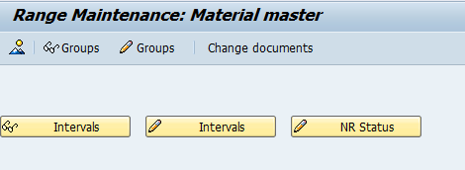
It will show the screen where you need to click on create
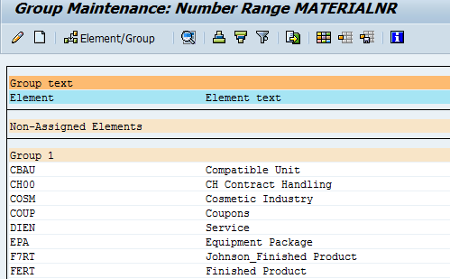

Now enter the Group name and number range data in the screen as under

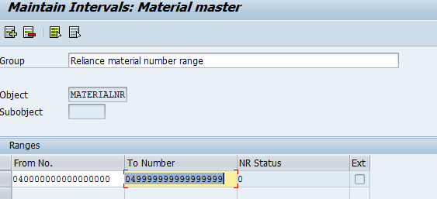

The group will be created with the entered number range and it will appear in the bottom of the page.
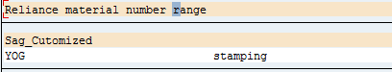

Now find ROH (row material) material type and click on new screen will pop up

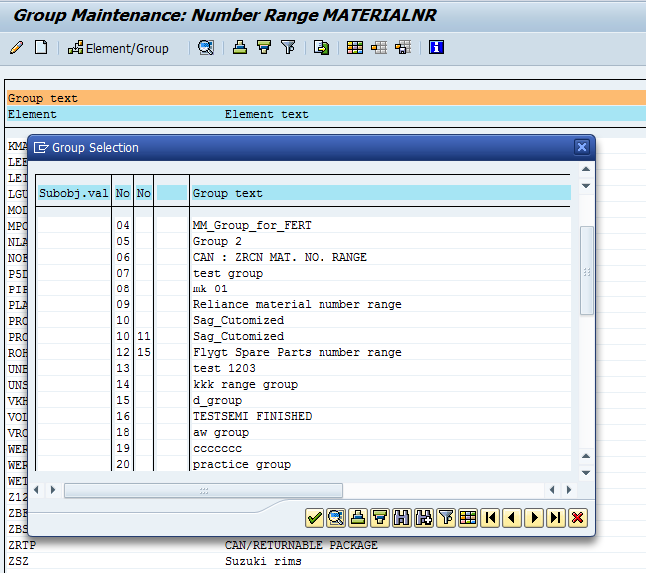
Here you can assign your Material type to your define material number range group. Material number range to ROH material type
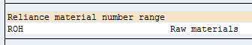
Let’s cross verify whether the assigned number range is working for that material type or not
- Create Material with material master using path SAP MENU→Logistic→Material Management→Material Master→Material
- Tcode-MM01

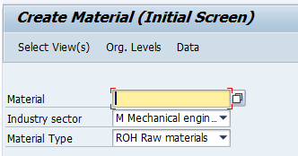

Now it will open the basic data view of material master here you can see the material number
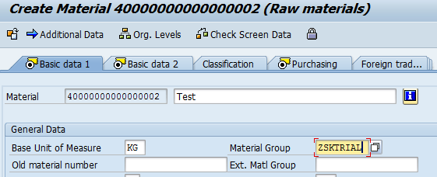

1.2) Create number range for BP/vendor master
To create vendor master number range use TCode omsj
Path SPRO→Logistic-General→Business partner→Vendors→control→Define number range for vendor master records.
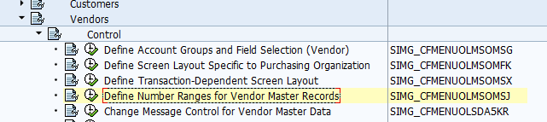 New screen will appear where you have to click on Intervals 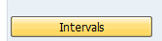
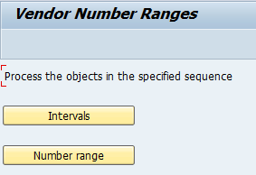

Here you have to click on create. Enter vendor number range & tick on external 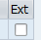
To use it as external number range and save it
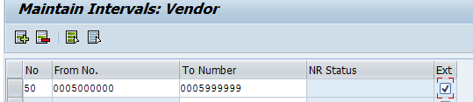
To assign this created vendor number range to vendor account group click on 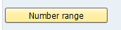 Here you have to enter number range that you had created in intervals against to vendor group
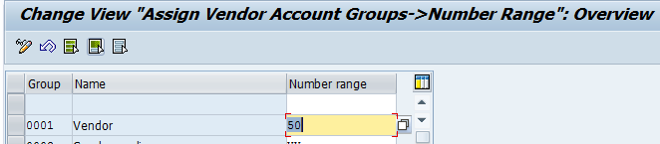
Let’s cross verify Vendor master number range for that we have to create vendor master Path SAP Menu→Logistics→Material management→Purchasing→Master data→Vendor→Purchasing→MK01
For external number we have to enter external number range in vendor field. Enter current vendor number rang in vendor field. Put vendor, purchasing organization, Account group.
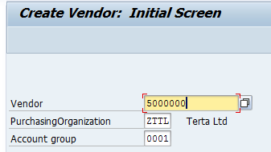
After filled the purchasing data the vendor master created with number range that we had define in vendor number range

Business Partner Creation:

Enter T code BP

Click on Organization Tab, First create Business partner General by entering all the data’s
Necessary, save BP.

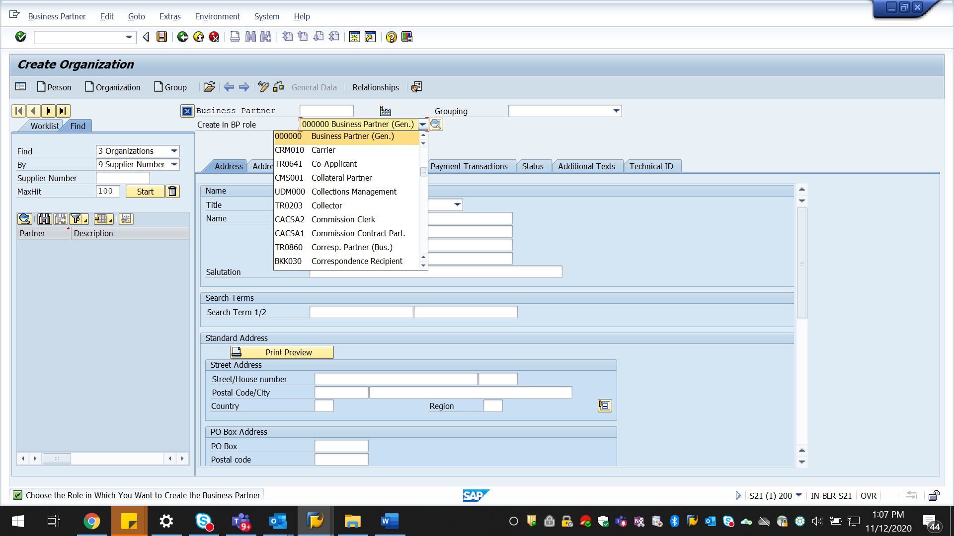

BP 10510 created

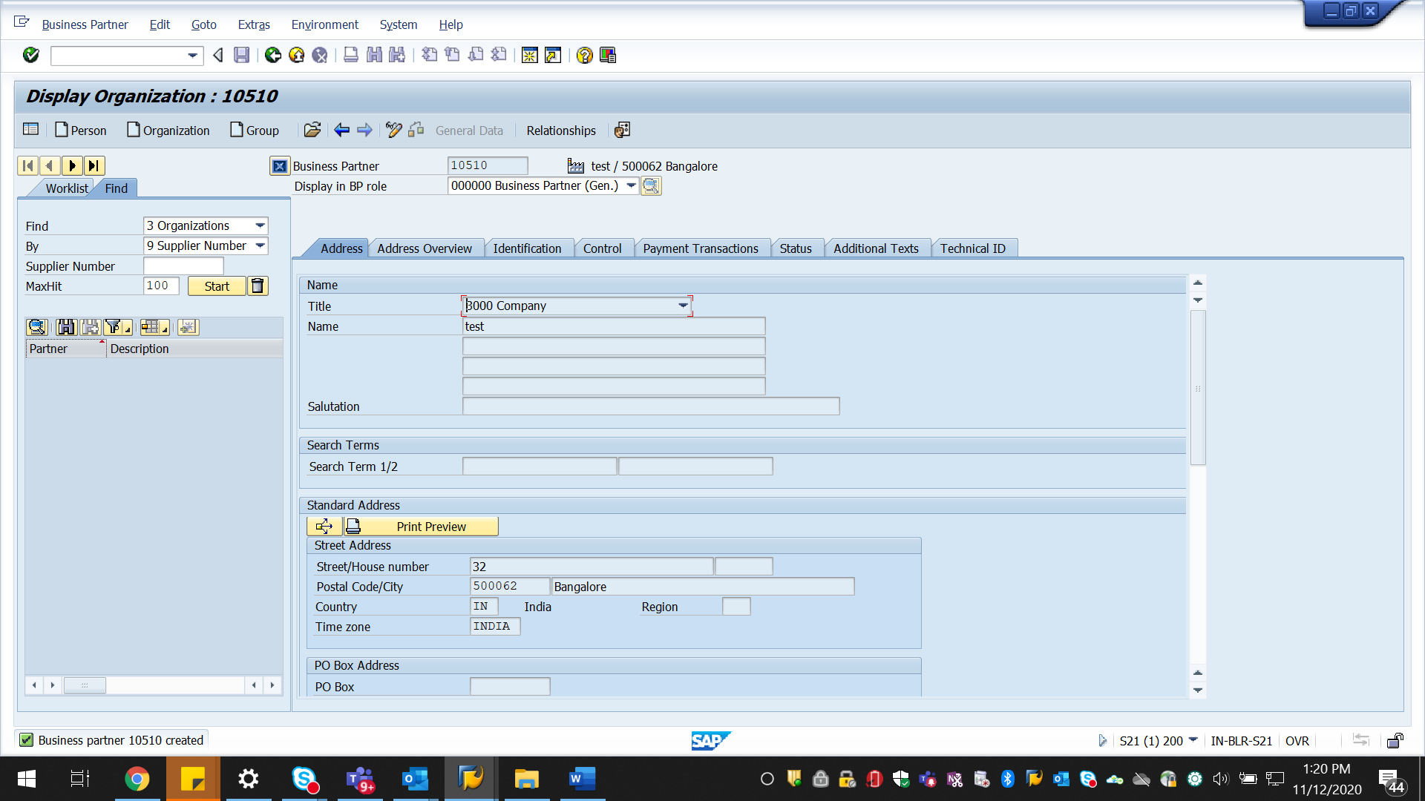

Extend BP 100140 to Purchasing (FLVN01) and Company code level (FLVN00)

Click on Purchasing tab and enter the details and save, BP extended to Vendor role

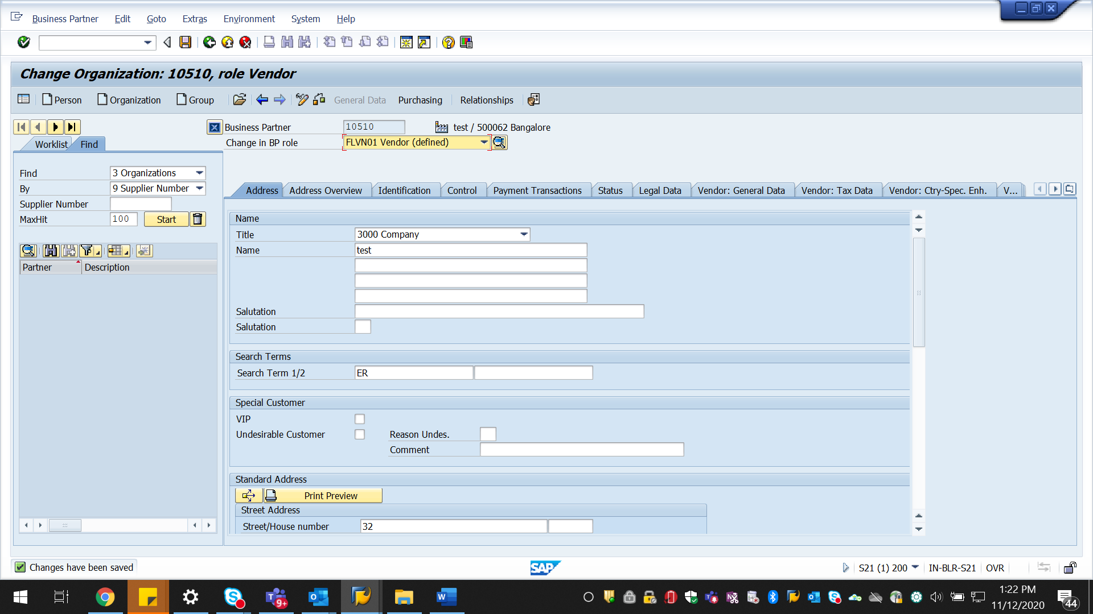

Both BP and vendor numbers are triggering same numbers because of Master data syncronization

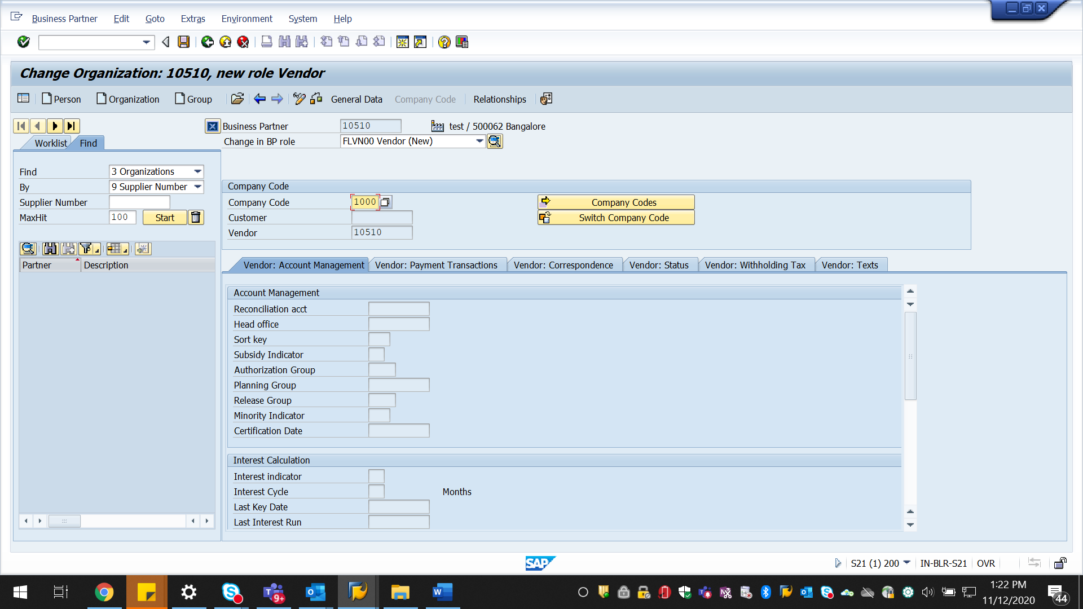

Same Number ranges for BP & Vendor will triggering based on this configuration settings
Under the below path select the BP account group 0006 and Vendor account group KRED
And tick the column Same Nos. to select the same numbers for BP and Vendor.

Cross application components-Master data synchronization-Customer/Vendor Integration
Business partner settings-Setting for vendor Integration-Assign keys-Define
number assingment for direction BP to vendor

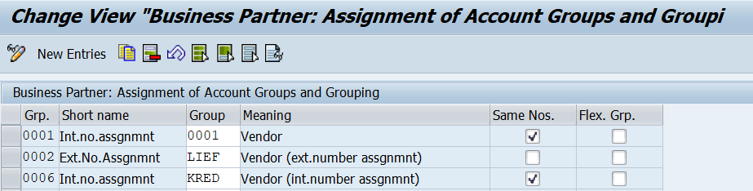

Create supplier/vendor account group under this path

Logistics General-Business partner-Suppliers-Control-Define account gropus
and field selection

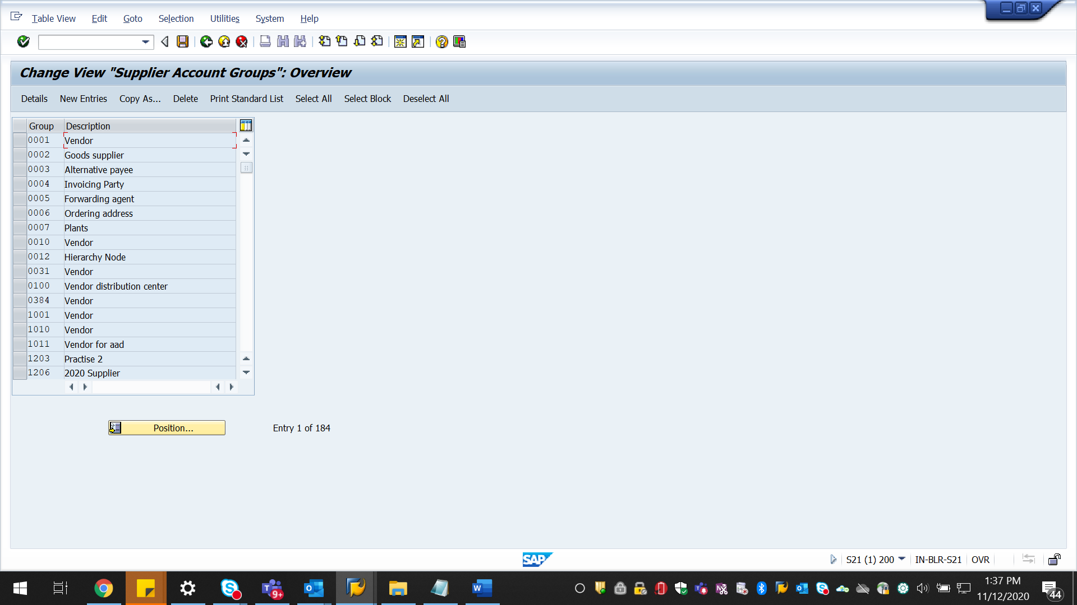

Logistics General-Business partner-Suppliers-Control-Define number ranges for supplier
Master records

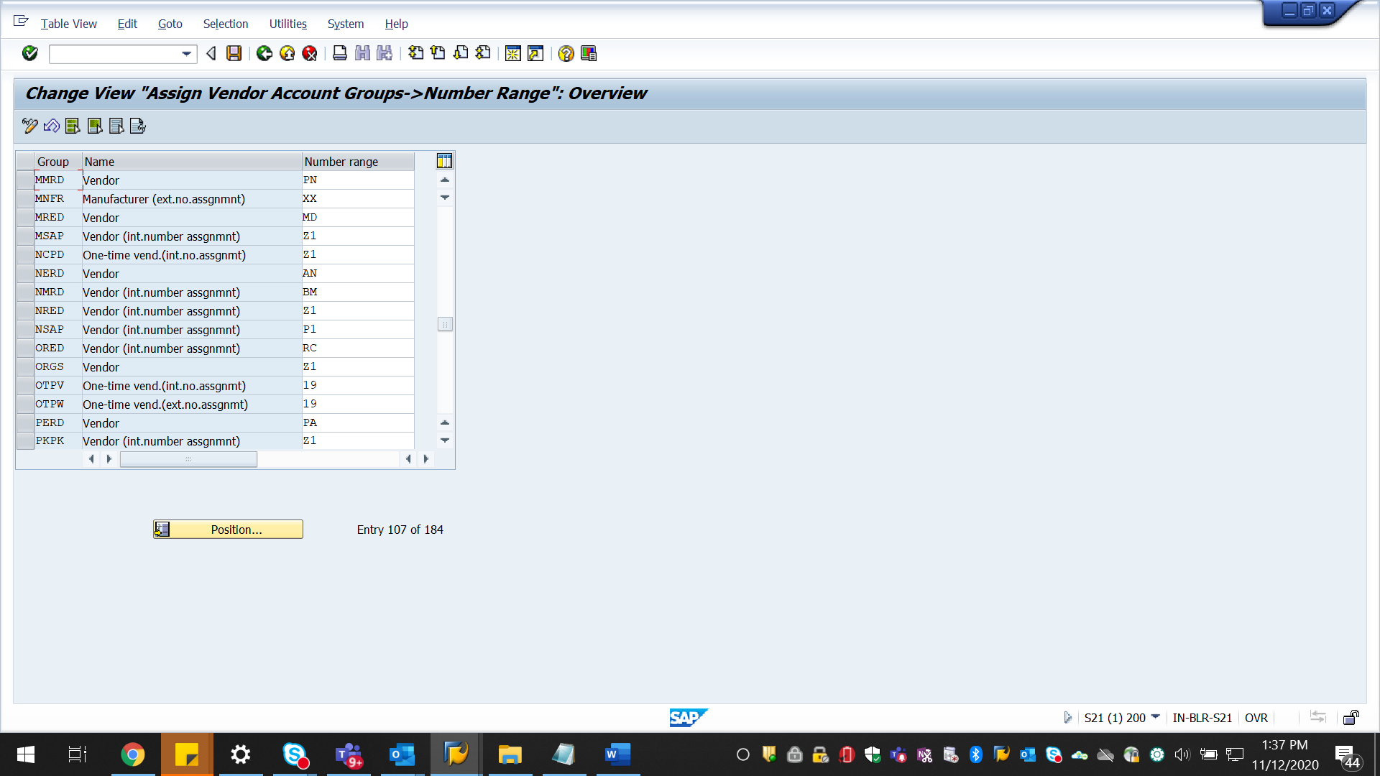

Create BP account group and maintain same number range as maintained for Vendor/Supplier

Cross application components-SAP Business partner-Business partner
Basic settings-Number Ranges & Groupins-Define Groupings and Assing number ranges

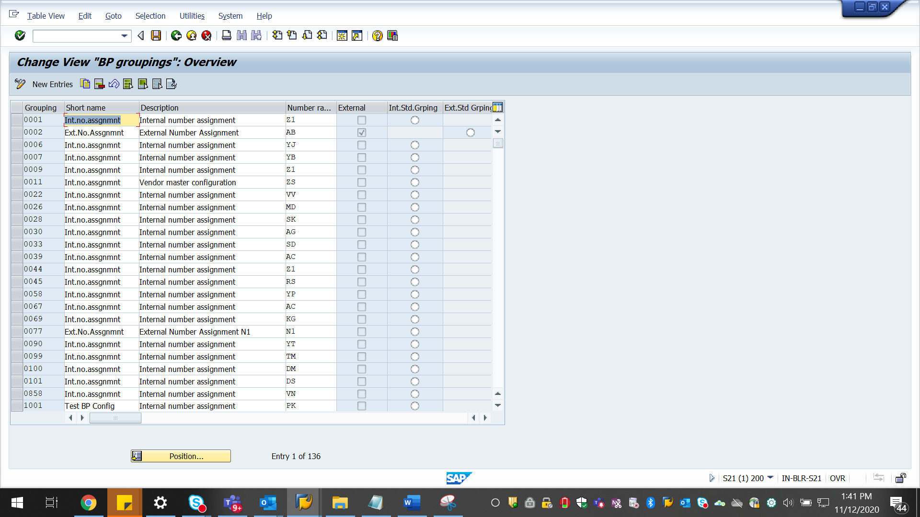

LAB 2)
Define customized reason for Movement Type?
Explanation: This reason is responsible only for certain movement type that you defined during Goods Movement like Return to vendor, Scrap etc. to set a customized reason follow the given path.
Steps:
Path: SPRO → Materials Management → Inventory Management and physical Inventory → Movement Type
TCode: OMBS

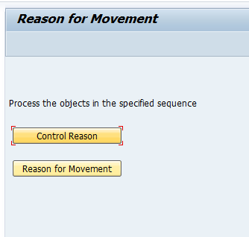

1) Control Reason: Here you can specify the Movement type should require a reason or not. For that first all the movement types are given/mentioned already in reason tab you will get 4 types of symbol where each has a specific meaning as follows

Control Reason Short Description

Entry in this field is optional.
+ Entry in this field is required.
- Field is suppressed.
. Entry in this field is optional.
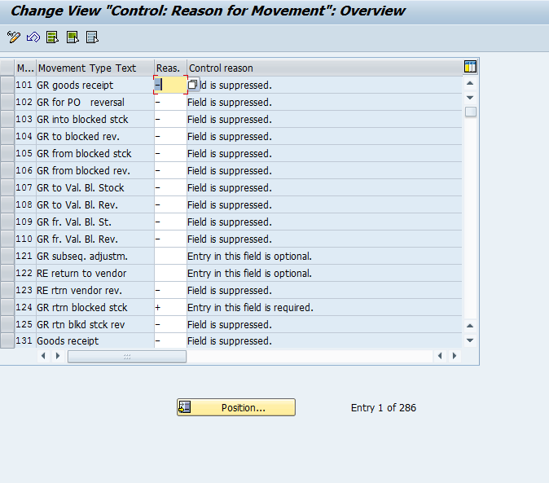

2) Reason for Movement:
New Entries: Define the movement type specify the reason along with the description save it.
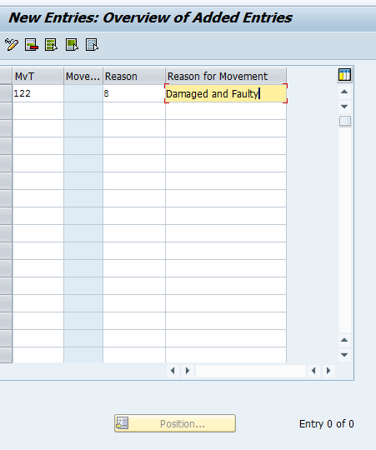
That’s all now while doing Goods Movement with transaction type 122 you can able to see the reason that we just specified here as shown below.

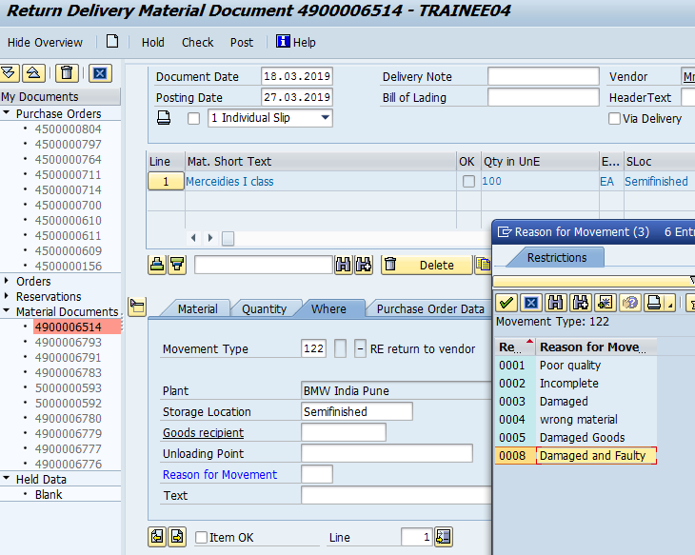

Accordingly when you want to specify a customize movement reason you can do that by referring above steps.

LAB 3) Automatic PO Creation
Auto PO means creation of Purchase Order Automatically in SAP while doing the Goods Receipt. In order to see that the POs to get created automatically, there are some prerequisites to be defined in the system.
1. Material Master Data :
a) Material Master (MM01). Proper material master needed to get created for the material with all the relevant data for Purchasing and MRP to get filled.
b) A check Box for Auto PO in the Purchasing View to be checked.
Path:
SAP Menu > Logistics > Material Management > Material Master > Material > Create > MM01.

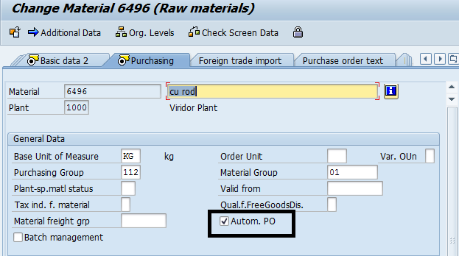

2. Vendor Master Data:
a) Vendor Master (XK01) needed to be created for the company code of the plant by which the PO is to be created and to be created for the Purchase Organization by which the PO is going to be created.
b) The Auto PO check Box in the Purchasing view needed to be checked.

Path:

SAP Menu > Accounting > Financial Accounting > Accounts Payable > Master records > Maintain centrally > XK01-Create or change XK02.

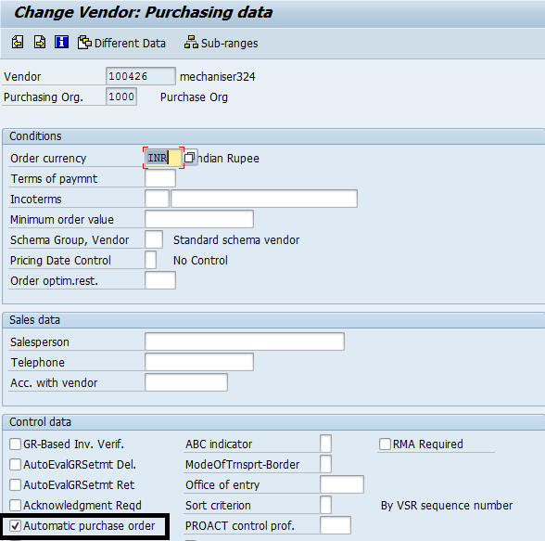
3. Source List :
A valid source list which is fixed for a vendor need to get existed in the system.
It is a List created in the system under a plant for a material which links to possible vendors for the material supply. Furthermore the source list will have validity and a vendor can be fixed in the system for supply.

Logistics ⇒ Material Management ⇒ Purchasing ⇒ Master Data ⇒ Source List ⇒ Maintain
T Code: ME01

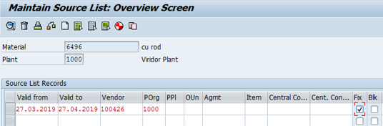

4. Info Record:
A valid Info record must exist in the system. Info Record is a record created in the system for a vendor and material for the purchase Organization and Plant through which the PO is going to be created. This can be created at the Transaction code ME11
Path:
SAP Menu > Logistics > Material Management > Purchasing > Master data > Info records > Create>ME11>Change>ME12.

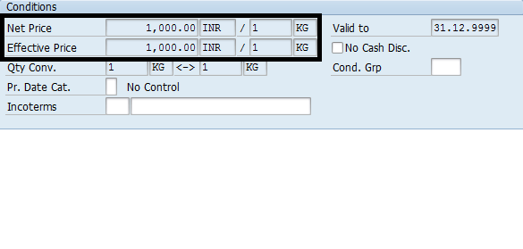
5. Purchase Requisition:
Purchase Requisition Creation through MRP or through ME51N screen.
In that assign a source of Supply: During the creation of the PR, system needs to assign a valid source of supply to the Purchase Requisitions. Means system is deciding about the vendor who has to supply the requirement at the Requirement generation only. In Order to happen this master data which has been defined earlier will serve the purpose in the order Outline Agreement or Info Record or Source list. With this step, system generates the Purchase Requisitions with a vendor assigned.

Path:
Logistics ⇒ Materials Management ⇒ Purchasing ⇒ Purchasing Requisition ⇒ Create ME51N OR Change ME52N.
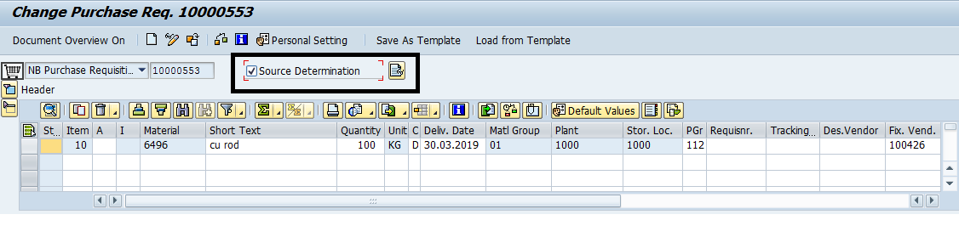

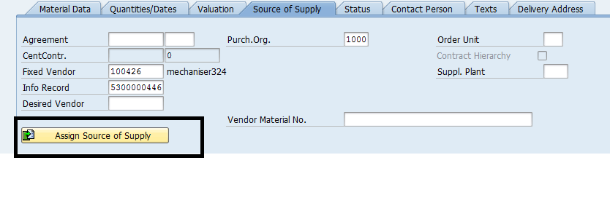
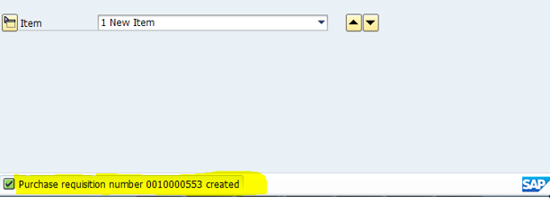

6. Creation of PO:
With reference to purchase requisition no. automatic PO will be created.
T code: ME59N
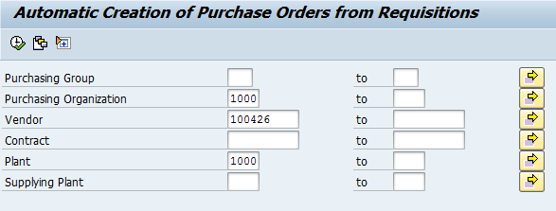

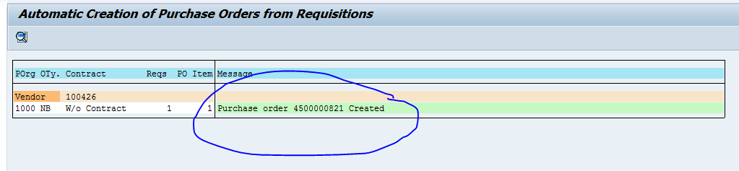
Purchase Order created.

LAB 4) Mass Maintenance of Materials

SAP mass maintenance is a process of changing multiple master data entries at once. Mass maintenance of master records is required when there are a lot of existing master records and you need to change certain data fields in those records
SAP MENU→ Logistics →Material Master →Material →Mass maintenance (Tcode-MM17)
1) System will show the screen where you can see different table and there filed tabs

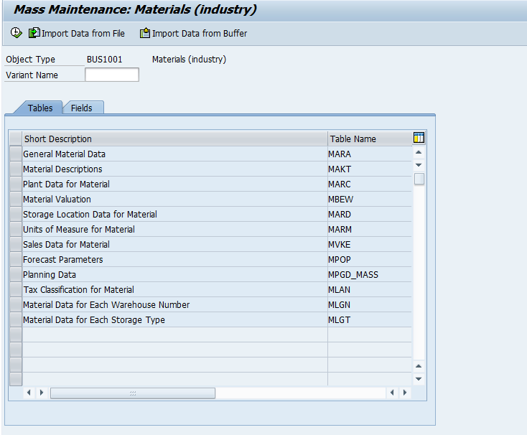

2) Click on filed where you can see all fields related to MARA table. Select on Material group field MARA-MATKL execute it
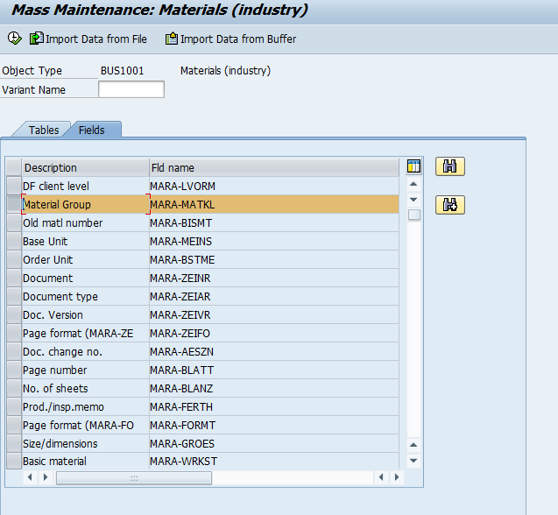

3) Enter the range of material numbers that required for Material group for mass change and execute it

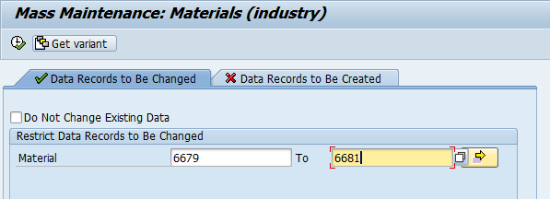

4) Now the system will show you the materials you selected and their existing Material Groups.in our example, we have material group as 01 and we want to change Material Group in all these materials to 02. Therefore this value should entered in New Values field. For that please click on Carry out Mass Change button
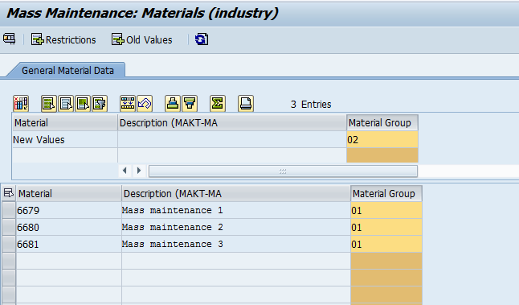

5) You will see that Material Group will be changed to 001 for all materials as required. Finally click on save button to save the changes.

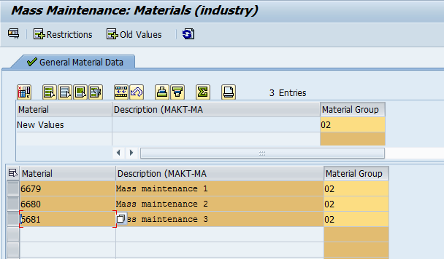

Once the changes are saved, you will receive a message.
Notifying that all the changes have been correctly executed.

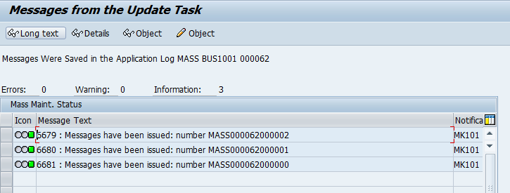

Check the results for Mass maintenance
After completion of mass change for materials we can cross check it by opening material master record.
SAP MENU→Logistics→Material Management→Material Master→Material→Change (MM02)

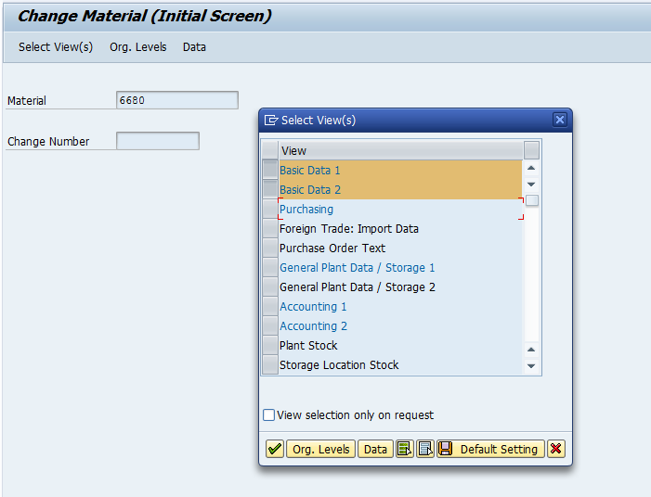

On the next screen you will see that Material Group has been successfully changed
through MASS transaction from 01 to 02.

